2017 POST EVENT REPORT
TEDx XavierUniversity

Prepared by: Kush Nayak, Ebube Iheme and Casey Smith
Xavier University | Office of Student Involvement

TEDxXavierUniversity

WOX Influence-
In our second year a as a WOX grant recipient, TEDxXavierUniversity was awarded financial and logistical freedom. We were able to be provid our guests with a unique experience and tangible take-aways. Our well received and unique stage design was a direct result of WOX support. This stage was equipped with an 16 foot TEDx XavierUniversity that gave a professional TEDx feel and will displayed prominently on the TEDx Talks YouTube Channel. As the presenting sponsor for TEDxXavierUniversity, WOX allowed us to plan and produce an event that we are proud of and that the University and local community deserve. Our goal is to inspire conversations and spark new, inventive ways of thinking on campus and in the Greater Cincinnati Area at large. With the WOX grant, we were able to focus more on ensuring each guest received a memorable experience rather than individual costs of such a large event event.
Theme selection-
Challenge:
- Collaborating as a club to explore a relatable theme for student and local community.
- Creating an original theme that was not widely used by TEDx community.
Success:
- Balancing differing perspectives to agree on a broad, malleable theme
- Giving guests a lasting experience

At the beginning of the semester, we worked to balance the perspectives of students with different majors and interests with TEDx’s requirement of developing an inclusive event theme. In previous years, we had a more direct/steering theme (2016 Hope: A Driving Force into the Future). This year, we wanted a positive theme that was less steering and gave us more flexibility in terms of the talks we could include. With increased support from the WOX grant we were able to facilitate engaging, and dynamic discussions at meetings, which helped us decide on this year’s theme, Luminescence. Our descriptor - Luminescence can be a twinkle, a light, or a vision that reveal something or provides guidance and a path forward. So the question is, what are you illuminating?

Speaker application process-
Challenge:
- Receiving a record number of applicants, but a disproportional male to female ratio.
- Developing an “idea worth spreading” with each speaker.
- Speaker talk refinement/logistics
Success:
- Leveraging our connections within the community and on campus to generate interest and increase applicants.
- Discovering new connections for future speakers.
- Developed new and intriguing speaker topics.
- Well-received student emcee

For the first time in four years we welcomed a student speaker - Taylor Zachary! Typically, we shy away from student speakers due a lack of perceived ethos from the audience. But after receiving numerous nominations including one from Dave Johnson, Associate Provost and Chief Student Affairs Officer. We believed the student body would be excited and receptive to Taylor Zachary’s talk. Our biggest challenge every year is finding speakers whose “idea worth spreading” connects to our event theme as well as had the qualified background to speak on the matter. A particular challenge we faced this year concerned a speaker who had a great idea, but a difficult time refining and committing the talk to memorization. As a team, we were able to guide this speaker and refine his talk by pinpointing key takeaways. As a result, the speaker was well received on event day. Overall, we had four diverse and engaging speakers who made our event the most highly rated TEDxXavierUniversity’s in the past six years.

On Campus Interest-
Challenge:
- Engaging students from the start of the event to the finish.
- Initial ticket sales.
- Establishing recruitment pipeline.
- Working with Student Advertising Resources (digital signage, student weekly news)
- Lack of marketing team.
Success:
- Kennedy Auditorium remained full from start to finish, we did not have a drop off in audience presence
- Generated record high ticket sales and first time attendance
- Started a new partnership with Xavier P.R.S.S.A

With WOX Support and increased support from Student Government Association we were able to enhance the “TEDx experience” greatly this year through gift bags! Each gift bag contained various items such as 3D printed Blobs, stainless steel water bottles items that fit a sustainable theme. We wanted audience memebers to walk away with something in hand after the event a that reminded them of TEDx Xavier. Through face to face interaction, we learned that a large portion of the audience was attending their first TEDx event, how they learned about TEDxXavierUniversity, and their own personal thoughts on Luminescence. Due to a lack of dedicated marketing team this we sought out a new student club partnership with Xavier’s Public Relations Student Association. Combined, we ran a seven-day promotional campaigning partnering with the Williams College of Business media liaison (connecting with external media) . As a result, we recorded the largest number of attendees ever in our six-year history. As the current leadership is transitioning out of their respective roles the next step is to bolster recruiting for the 2018 campaign.

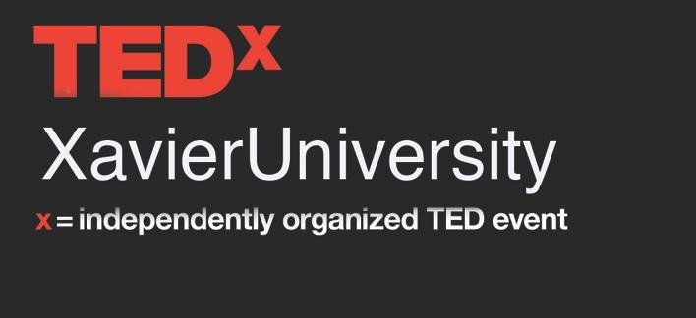

Pictures taken on Event Day: (Google Drive Photo Link)
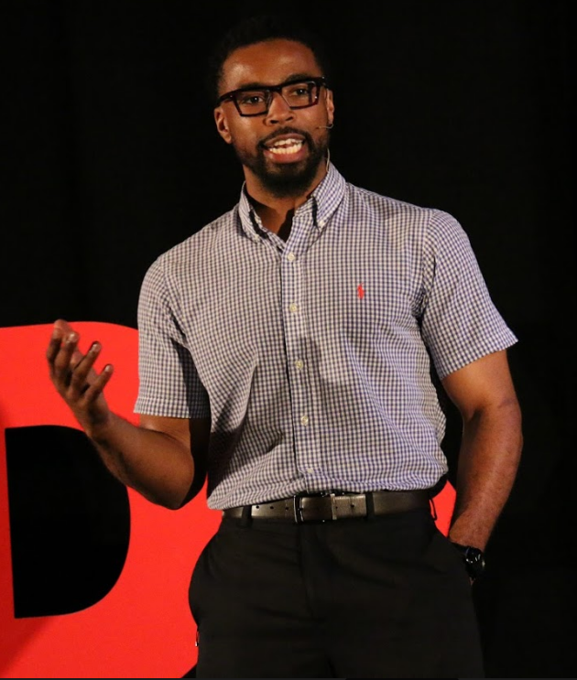
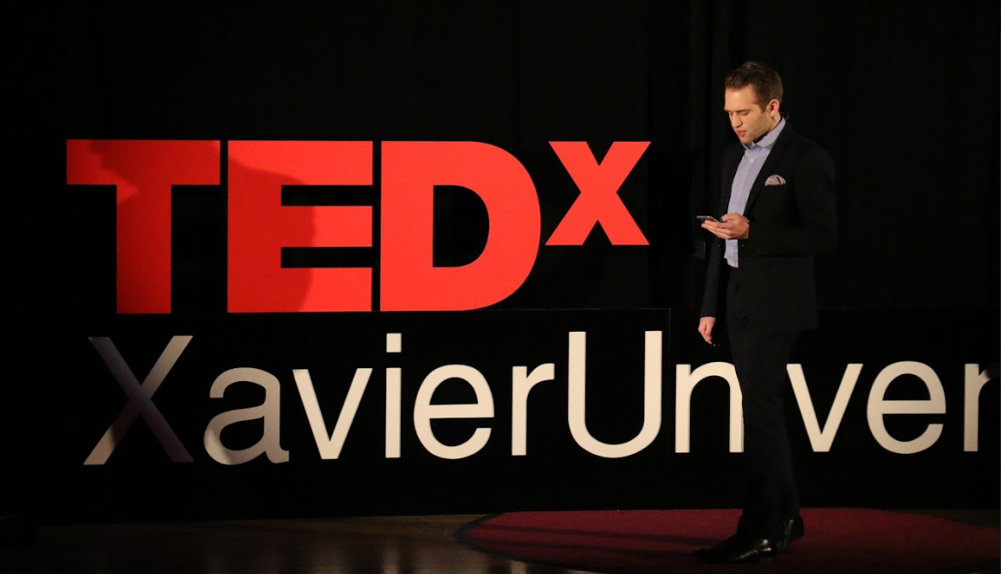
Zach Huhn, Speaker
Taylor Zachary, Speaker
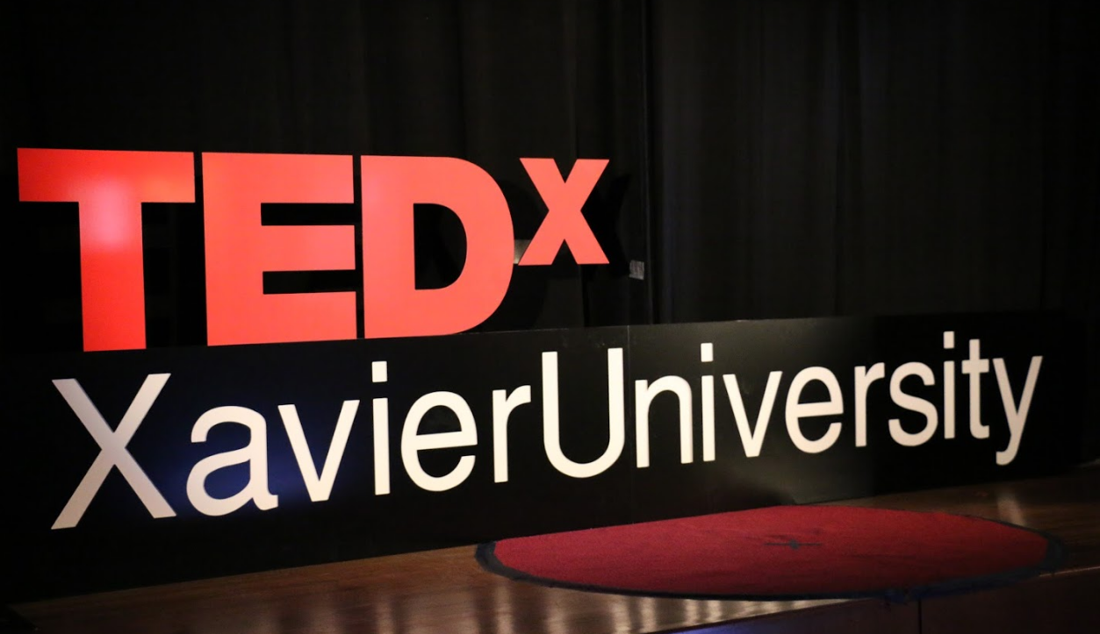

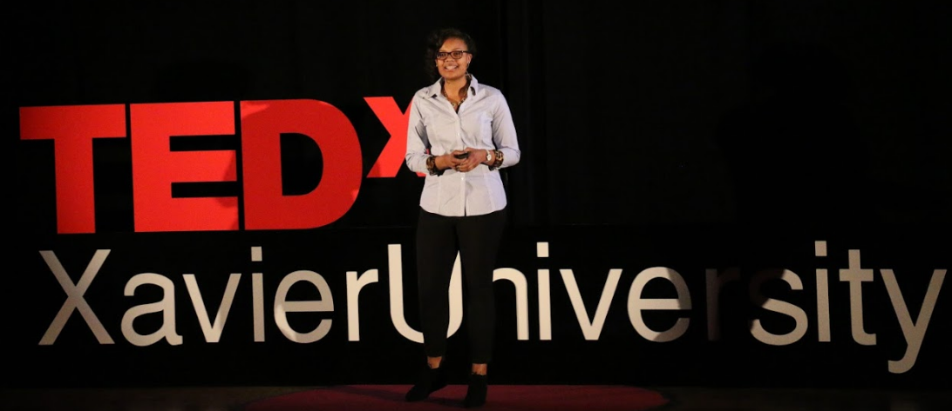
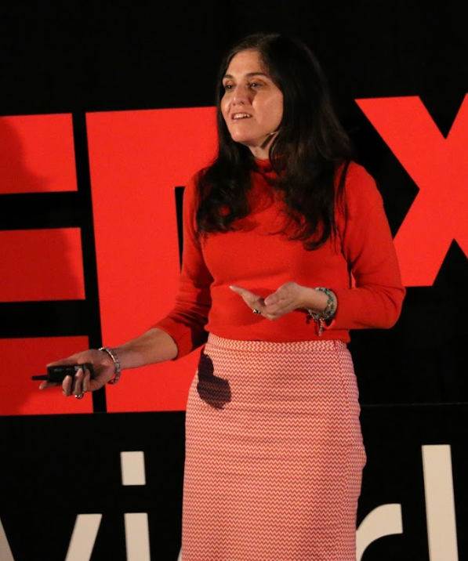
Hannah Sheppard, Emcee
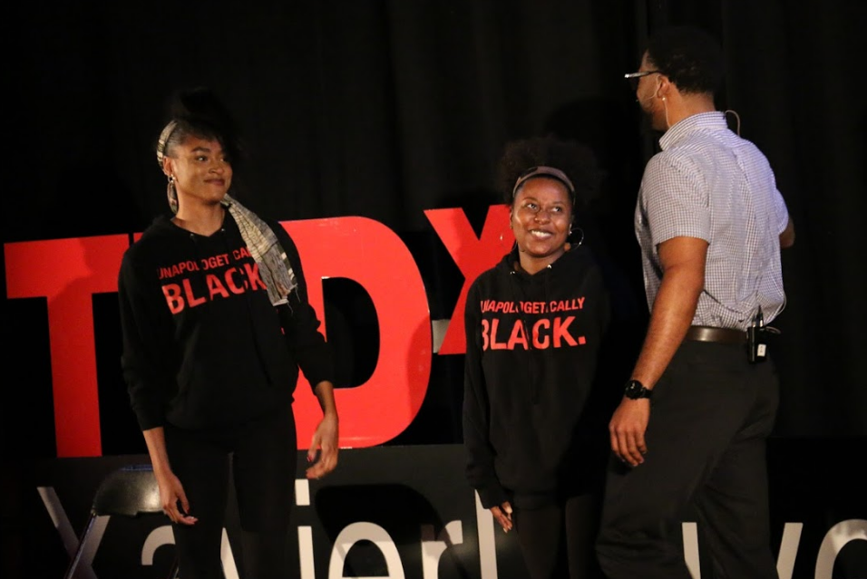
Taylor Zachary, Speaker – far right
Angela Mazzi, Speaker
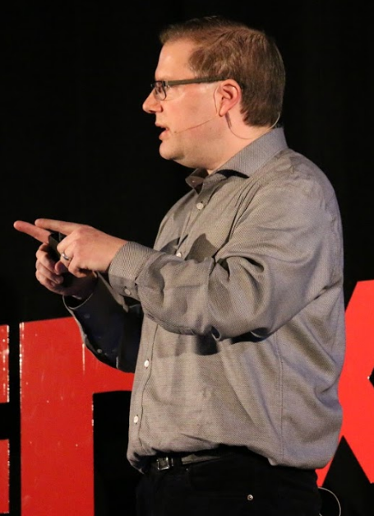
Ryan Niemiac, Speaker
